DECEMBER Region 2 NEWSLETTER 2021
Dear Region 2 Professional Members,
I hope this Newsletter finds you well and looking forward to the 2022 season.

USAG updated policies on Covid protocols. Please see sanction_nonnational.pdf (usagym.org) to read the document. Essentially, it is now saying for state and regional meets only the local CDC guidelines need to be met. Westerns and Nationals will still have a mask mandate requirement in place. We are experiencing a COVID surge, but you are well prepared to have the necessary protocols in place to provide a safe event for the athletes; coaches; officials; staff; families and friends.
USA Gymnastics has updated COVID guidance to assist event directors and participants.
As the season progresses - the protocols for the 2022 Regional Championships will be monitored and shared with the membership.
Updated COVID guidance Link

There are several items that require your attention as we move into 2022:
Most important! Do you have SENIORS in high school? We need a LIST for Level 7,8, 9, and 10 and Xcel Gold, Platinum, and Diamond. Sadly, last year there were athletes at regionals who came at the end of awards when we asked if there was anyone else and said they were a senior and we did NOT have them listed. There was at least one every session! PLEASE send me your names. We also want to make sure we have enough senior gifts for them.

U 112 Tough Coaching or Emotional Abuse Course Link
Failure to complete this course by January 10, 2022, will result in your membership being placed in pending status. Review membership requirements here .

USA Gymnastics offers Health Insurance benefits Link

Save the date- Regional Congress dates are August 13 and 14 at the MAC Club in Portland. Testing for Nationals and Brevet judges will be provided. There will also be a U200 course offered. More to come.
Sad news- Merge Eilers, a longtime judge in Washington, has passed away.
Thank you to everyone who help to support the leotard fundraiser. We made $4500! Our other fundraiser is going great! Please put it out to your parents and have your clubs donate. So far, we have club donations from Emerald City Gymnastics, Island Tumblers, Naydenov Boosters, and PEAK. We also have several donations from families.

In closing, thank you for your commitment to USA Gymnastics Region 2.

Best wishes for a happy and healthy 2022,

Marian DeWane

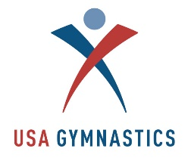

Settlement with Survivors approved by court; USA Gymnastics to exit bankruptcy

USAG balloting passed the proposal settlement and hopefully USAG will exit bankruptcy in the coming months. The proposal has the region getting 80% back what is owed over a three -period. We should get between 3000 - 3500 a year for the three years.
USA Gymnastics to Exit Bankruptcy and USOPC will continue to recognition of USA Gymnastics as the national governing body of the sport. Read more HERE.

Updated COVID Guidance for Non-National Sanctioned Events

The updated guidance for Sanctioned Events, including state and regional competitions, can be found HERE .

USA Gymnastics highly recommends and encourages all sanctioned event participants and spectators to follow CDC guidelines throughout any USA Gymnastics sanctioned competition.

We remind event directors and clubs that sanctioned events are required to be conducted in a manner that is permitted by, and in compliance with, their local government guidelines.
Event Directors should communicate their specific event’s facial and social distancing protocols in pre-event and on-site communication. USA Gymnastics has developed signage and flyers to help meet directors with this communication. Click here to view.

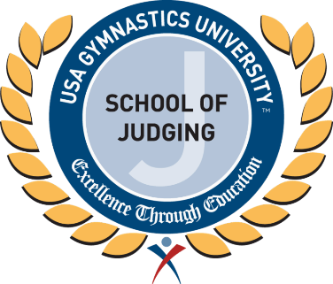

XCEL JUDGES COURSE
The XCEL Judges Course is up and running. Cost is $15.00

It is designed for: Anyone who would like to judge Xcel
- Currently Rated Judges - for review and/or to earn 5 CPE clinic credits
- Retired Judges who previously held a Level 9 or higher rating
- Parents, coaches, gymnasts (16 and older) and parents who want to become involved with judging

Regional Calendar:
April 21 – 24 DP Regionals Naydenov Clark County Event Center Vancouver
April 29 – May 1 Xcel Regionals NW Aerials Gary D. Weikel Event Center Evergreen State Fairgrounds, Monroe, WA
May 6 – 8 DP Westerns Lindenwood U St. Charles, Missouri
May 13 – 15 DP Nationals Legacy Sports Bell Bank Park, Mesa, Arizona
August 13-14 Regional Congress MAC Club, Portland, Oregon
State Meet Calendar
Alaska
March 25 - 26 Alaska Optional State Meet
Hawaii
January 23 Compulsory State Meet HITS - Honolulu
March 25 – 26 Optional State Meet HITS
Idaho
March 18 - 20 Xcel State Moscow - Palouse
March 25 - 27 DP State Boise - Bronco Elite
Montana
March 25 – 27 Montana State Bozeman - Lone Mountain
Oregon
March 18 - 20 Optional State Portland area – Westside
April 8 – 10 Xcel State Medford – ABK
April 8 – 10 Compulsory State Eugene - GNW
Washington

